URL and Attachment Analysis
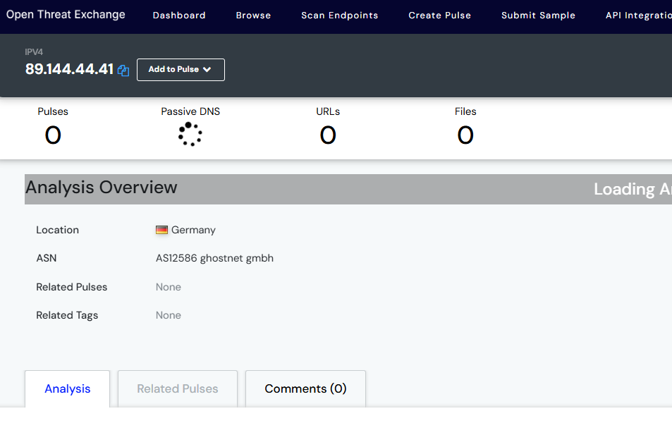

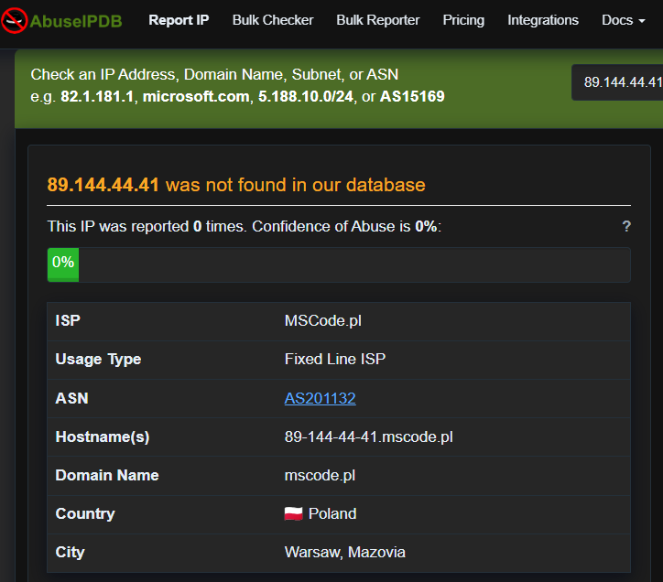
Figure4 : image showing status of IP address

Even though the IP address was not reported as malicious at Virus total,AbuseipDB, and AlienVault , there is a discrepancy in location. AbuseipDB reported that the IP originated from Poland, AlienVaulted reported that IP originated from Germany while the email header indicated that email came from Russia.
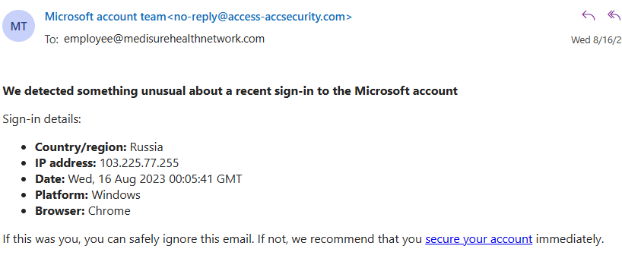
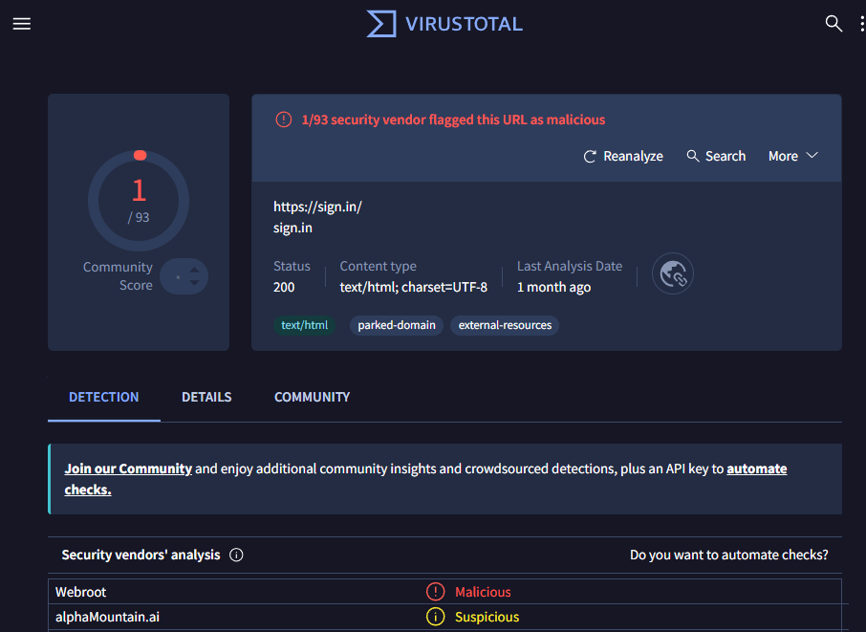
Figure5 : images showing phishing link embedded in mail and result of phishing link analysis.
When i hovered the mouse on the link “secure your account” it redirects to https://sign.in/.
As shown in figure5, this link had once been reported at VirusTotal:as malicious.

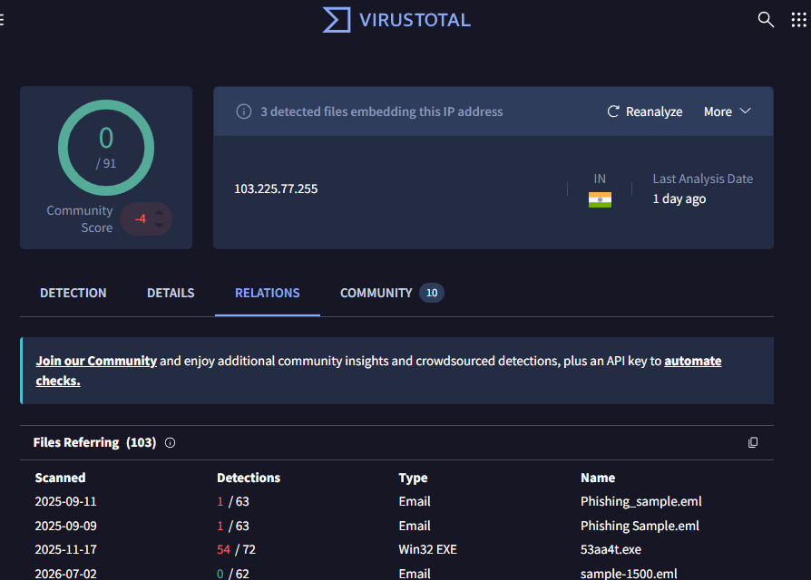/sign.in/
Figure 6: image showing status of IP 103.225.77.255 shown in the mail.

The image shows that there are 3 embedding files in this IP address, this is very critical as these files could be unloaded into the organisations system if link was clicked//sign.in/

